**Temperature Correlated Changes in Relative Abundance of Mollusks at Dead Man’s Bay, San Juan Island, Washington**

Jamie Andersen Fields1

Study Participants: Sean Dougherty1, Cormac Toler-Scott1

FHL 470: Research in Historical Marine Ecology 2018

Spring 2018

1Friday Harbor Laboratories, University of Washington, Friday Harbor, WA 98250

Contact information:

Jamie Andersen Fields

[joymfay@uw.edu](mailto:joymfay@uw.edu)

*keywords*: mollusks, *Littorina*, *Katharina tunicata,* climate change

Abstract

Globally temperatures are rising and the oceans are acidifying, which may pose risks to intertidal communities, which already experience large variability in conditions. Laboratory studies have shown increased temperatures and decreased pH may reduce survivability of mollusks and alter their interactions with the larger intertidal community. Under increased temperature, mollusks appear to have increased metabolism and a reduction in adult body size. Additionally, low pH conditions may disrupt their ability to properly form shells and result in reduced shell thickness, increasing susceptibility to predation. While laboratory studies show potential impacts of climate change on intertidal mollusks, we need more data on how communities have changed in the field. We examined changes in community composition at Dead Man’s Bay, San Juan Island, Washington, USA and found that mollusk populations have remained largely unchanged since 1973, except for an increase in small limpets and *Littorina* snails, and a decrease in a large grazer, *Katharina tunicata*. Increases in small gastropods and decreases in large polyplacophores is correlated with our expectations under climate change. Smaller individuals have previously been shown to handle greater thermal stress, which we would expect with warming oceans and air. Changes in other groups and trophic levels were largely correlated with our expectations under climate change, and may have also impacted the molluscan groups studied. Utilizing historical data allowed us to consider the longer term impacts of changing conditions, even if it does not allow us to assign causation. We believe that further comparison of current communities to historical data will provide greater temporal and spatial data on the possible impacts of climate change in the intertidal.

Introduction

Anthropogenic carbon dioxide emissions have driven global climate change and ocean acidification. From 1800 to 1994, approximately half of anthropogenic carbon emissions, or a total of 118±19 petagrams of carbon-dioxide have been absorbed by the ocean (Sabine et al 2004). This has resulted in a decrease in pH of 0.1 units since the pre-industrial era, and under current anthropogenic carbon-dioxide emission rates, pH could drop another 0.4 units by 2100 (IPCC 2001; Feely et al 2004). Global temperatures have also risen; in the past 100 years, atmospheric temperatures have risen approximately 0.6ºC, while sea surface temperature has risen 0.78ºC in the same time period (IPCC 2001, NOAA).

Intertidal communities deal with large changes in temperature and pH on a much shorter time scale, conditions swinging between extremes with the tides. The conditions and challenges of the inter-tidal govern the distribution of organisms and community interactions. With climate change and ocean acidification altering conditions, we might then expect to see changes in community ecology. Some populations may be more negatively impacted by increasing temperature, but in some cases, those negative impacts are not affecting interactions with other trophic levels; Morelissen and Harley found that while micro-algae suffered and decreased in abundance under increased aerial temperatures, their grazers were not significantly impacted (2007). Species composition can also play major roles in controlling inter-tidal conditions and variability, meaning that loss of them may provide positive feedback on changing conditions; the presence of non-encrusting primary producers can increase pH and reduce its fluctuations within tide pools (Silbiger and Sorte 2018).

As mobile grazers and predators with species living across the entire range of the intertidal, have made them of particular interest for ecological and climate change research. While adapted to the extremes of the intertidal, there is concern for how they are faring and will fare with continuing climate change. Laboratory studies of a gastropod, *Lottia digitalis,* have established their thermal tolerance as 30⁰C aerial, which may already be exceeded in the intertidal during parts of the summer (Bjelde and Todgham 2013). Smaller gastropod individuals appear to have greater survival at increased temperatures, but the loss of large individuals may have greater impacts on populations as they contribute more to reproduction (Peck et al. 2009). Studies of *Littorina* shows that increased temperature can result in decreased shell thickness, but that the influences of increased temperature combined with low pH are more complicated (Melatunan et al. 2013). Increases in pH may also be a concern; *Littorina* snails exposed to decreased pH lose their ability of grow thicker shells as an induced defense against predators, instead exhibiting more energy intensive escape behaviors and making them more susceptible to predators (Bibby et al. 2007). When pH and temperature are both considered, these impacts are sometimes mitigated, or at least do not appear to be synergistic; shell thickness may be decreased but not as extremely as when only exposed to low pH (Melatunan et al. 2013). The complicated effects of pH and temperature on this group of intertidal invertebrates calls for more field studies and historical comparison.

Revisiting historical studies and completing resurveys allows us to look at how populations and communities have changed over longer time periods. While we are only able to look for correlations, rather than manipulate variables, we can still quantify change. There is a wealth of historical data, dating back decades if not a century, ripe for resurvey. Previous researchers have showed this to be an effective method at looking at community changes, a strong example being the study of kelp forest dynamics by Pfister, Berry, and Mumford (2017). Through historical comparison and long-term data sets, they were able to evaluate how a massive ecosystem has varied over time and could consider environmental factors in a way short term or laboratory work could not compare. We believe greater utilization of historical data will improve the scientific approach to studying climate change and ecology.

We evaluate changes in molluscan population density and relative abundance within the rocky intertidal of Dead Man’s Bay, San Juan Island, Washington, USA. Long-term sea temperature data from Race Rocks, Juan de Fuca, British Columbia indicates a 1ºC increase of sea surface temperature in the Strait of Juan de Fuca since 1921, compared to a northern hemisphere average sea surface temperature increase of 0.68ºC reported by NOAA in the same time period. The more intense warming at this site may be analogous to what other parts of the world will see in the coming decades. To determine changes to the mollusk community of Dead Man’s Bay, we surveyed mollusks in the rocky intertidal and compared our numbers to the 1973 survey of the site by Dwinell et al. We also compared any observed changes with local historical and contemporary data for temperature, pH, and other conditions. Based on previous studies, we expected to see decreased abundance of larger mollusks and a shift in community dynamics to favor success of predators that consume mollusks.

Methods

*Site Information*

Dead Man’s Bay is a publicly accessible preserve on the west side of San Juan Island, Washington. The study site is a rocky intertidal igneous outcropping along the North side of the bay (Dwinell et al 1973). The site has an abundance of tide pools, some isolated during lower tides, and other receiving water through surge channels.

*Historical Survey*

Dwinell et al. surveyed the study site April through May of 1973 to create a list of the present invertebrates and algae, and to quantify relative abundance of the two. They chose six random but relatively evenly distributed transects running from the high intertidal to the low tide line. They did not explain the process of randomization of transect lines, nor define the low tide line. Twenty 0.5 m by 0.5 m quadrats were surveyed along the first transect and 10 quadrats for the other five transects. Quadrat locations were selected using random number charts, with the random number being equal to a meter mark along the transect which the quadrat was centered on, and with quadrats being repeated if a number was drawn twice from the chart.

Within each quadrat, counts were taken of thirty-two invertebrate species, and estimates were made of percent cover for both the canopy and understory for twenty-seven species of algae. Relative abundance was calculated for all species.

In addition to the transect survey, Dwinell et al. completed an exploratory survey of the site and created a list of present organisms and their relative zonation.

Dwinell et al. also recorded the temperature of the air, sea, and tide pools, salinity of the sea and tide pools, precipitation, and tidal cycles over the thirty-seven day period.

*Determining Transects and Quadrats*

Using Google Earth, we compared the study site as drawn by Dwinell et al. to contemporary aerial photos as seen in figure 1. The resemblance of the aerial photos and hand-drawn map was convincing.

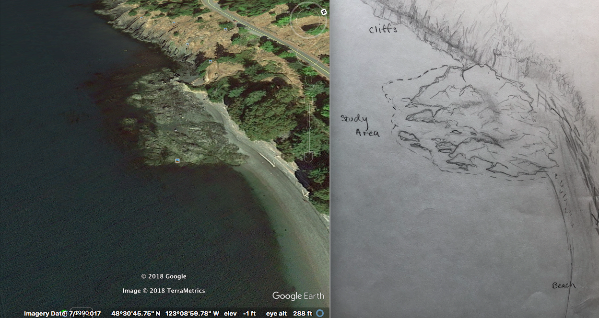 (a)

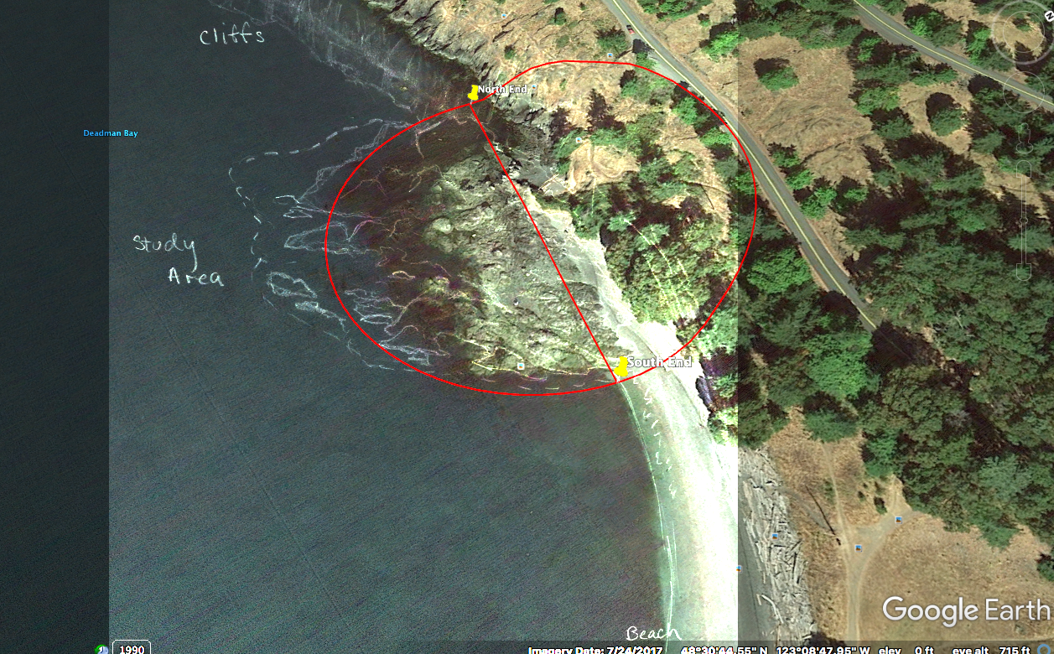(b)

**Figure 1- *Side by side comparison of contemporary aerial maps with drawings of the Dead Man’s Bay study site from 1973*. (a) Google Earth View of study site from 2018 on left. Hand drawing of study site from Dwinell et al. 1973 on right. (b) Overlay of hand drawn study site from (a) overlaid on Google Earth image from (a), using Adobe Photo Shop. Study site is circled in red, with the top of the study site marked with a red line across the diameter. For all images, North is the top of the diagram.**

We then used Google Earth to create a transect parallel to the beach running from the North to South above the splash zone of the study site, named Transect P. Transect P was used to determine the landward most points of the surveyed transects. Using an online random number generator, six transect end-points were determined, with the random number being the meter mark on the initial transect where the end-point was located. The transects were drawn perpendicular to Transect P and were each 55 meters long. The transect length was chosen to ensure that all transects encompassed from the splash zone to at least the Mean Lower Low Water line. Both the initial transect and the survey transects are shown on the map in Figure 2. Quadrat locations were defined as meters along the survey transect equal to numbers produced by a random number generator, with zero defined as the point on Transect P, in the case of transects three and five. For transects two and six, distance on Transect P was measured as distance from the low tide of the day, similar to Dwinell et al. Excess random numbers were generated so that any which were below the low tide or were prohibitive to sample were discarded. In advance of field work, transect GPS coordinates were extracted from Google Earth. Transect coordinates are summarized in Table 1. A Garmn eTrex 10 GPS was used to determine actual quadrat coordinates in the field; these are summarized in the appendices.

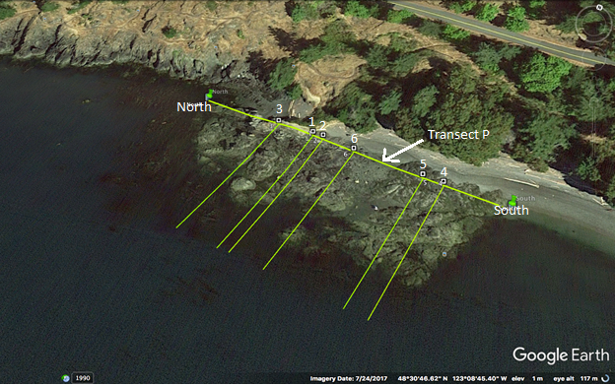

**Figure 2 – *Contemporary transect lines at Dead Man’s Bay study site*. Transects one through six originate perpendicular to Transect P, which is the transect running parallel to shore and which marks the landward edge of the study site. Transect numbers are based on the order which they were randomly generated. Transect lines and figure were generated using Google Earth.**

**Table 1 - *GPS coordinates of contemporary transect lines*.**

|  |  |  |  |
| --- | --- | --- | --- |
| Transect | Distance N-S on transect P [m] | Latitude | Longitude |
| 1 | 46 | 48º 30’ 48.04” | -123º 08’ 49.82” |
| 2 | 50 | 48º 30’ 48.02” | -123º 08’ 49.63” |
| 3 | 32 | 48º 30’ 48.13” | -123º 08’ 50.49” |
| 4 | 94 | 48º 30’ 47.75” | -123º 08’ 47.56” |
| 5 | 87 | 48º 30’ 47.79” | -123º 08’ 47.89” |
| 6 | 62 | 48º 30’ 47.95” | -123º 08’ 49.07” |
| North end | 0 | 48º 30’ 48.32” | -123º 08’ 52.00” |
| South end | 114 | 48º 30’ 47.62” | -123º 08’ 46.54” |

*Contemporary Survey*

Prior to surveying transects, we completed an exploratory survey on 20 April 2018 and created a list of observed species to compare with that by Dwinell et al., and to use as a starting point for species to count. The species list can be found in the appendices.

The contemporary transect survey was completed on 4, 15, 16 and 18 May 2018 around the lowest tides of the day. Due to time constraints from the availability of low tides, transects one and four were not surveyed, so only four transects were completed compared to six by Dwinell et al.

Following the methods of Dwinell et al., within each 0.5 m by 0.5 m quadrat percent cover of individual algal genera or species was estimated, with percent cover taking into account both the canopy and surfaces underneath. Due to this, total percent cover could be greater than 100%. Within the same quadrats, invertebrates were counted. A complete list of species counted can be found in the appendices. Compared to Dwinell et al., more genera of gastropods, crustaceans, cnidarians, and echinoderms were counted in the contemporary study, while worms were largely ignored.

When counting invertebrates, cobbles larger than 7 cm were flipped and all sides were examined, while pebbles and boulders were left in place. For quadrats where the number of individuals was too large to effectively count, subsampling was used to estimate counts within the quadrat. Similarly, when the conditions of the quadrat, such as large percent cover by algae, made it difficult to count invertebrates, individuals were removed and counted from the whole quadrat or from a sub-section and then estimated. Individuals were also removed and counted in the case of more motile invertebrates. This study focused on the bench rather than boulder fields, which were a small portion of the study site and a very distinct habitat, and quadrats that landed in boulder fields were discounted, and assigned to the next random number.

Average density of mollusks was calculated across all quadrats for both the contemporary and historical data. We also calculated relative abundance of molluskan species as the average across quadrats of individuals of a species or group divided by the total mollusks in that quadrat. This allowed us to look at how the ratios of population densities between species had changed rather than solely the absolute population densities. This is important as we did not survey the exact quadrats surveyed by Dwinell et al., and so if our sampling happened to land in areas generally with higher population densities, it could be difficult to see what these changes look like across the community.

Results

As expected, there was a large amount of variability in population density between mollusk species (Fig. 3). There was also a large amount of variability in population density across quadrats and transects (Fig. 3). In both 1973 and 2018, *Littorina* and limpets were the dominant groups present at Dead Man’s Bay (Fig. 3, Table 2). Comparing between years, there were few ecologically meaningful difference in population density across species. The exceptions included the group other limpets, which included all limpets excluding *Lottia digital*is and *Diodora aspera*. From 1973 to 2018 the average population density of other limpets increased from 36 individuals per m2 to 200 individuals per m2, a greater than five-fold increase. *Lirabuccinum dirum* also saw a meaningful increase in density, approximately tripling from 1973 to 2018 from 7 individuals per m2 to 22.5 individuals per m2.

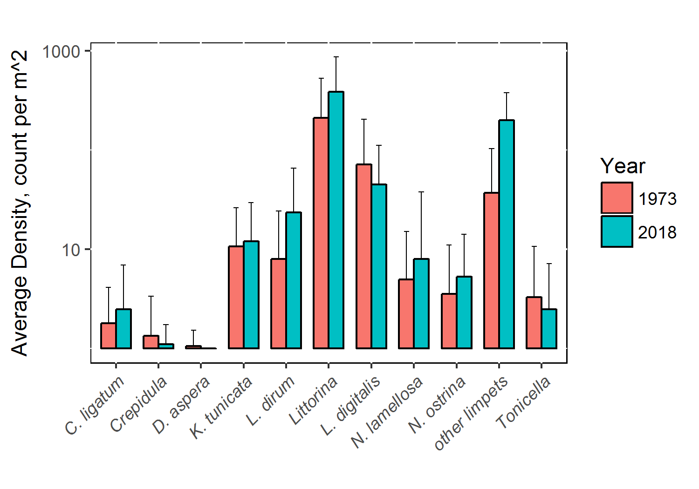**Figure 3 - *Average counts per m2 of mollusks at Dead Man’s Bay, 1973 vs 2018*: Counts of *Calliostoma ligatum*, *Crepidula*, *Diodora aspera, Katharina tunicata, Lirabuccinum dirum, Littorina, Lottia digitalis, Nucella lamellosa, Nucella ostrina, Tonicella,* andlimpets excluding *Diodora aspera* and *Lottia digitalis* averaged over all surveyed transects, shown on a base 10 logarithmic scale. Error bars represent one standard deviation above the average density. One count per m2 was added to the average densities to allow species with average densities less than one to plot on the log axis.**

**Table 2 - Average Mollusk Population Densities at Dead Man’s Bay in 1973 and 2018.**

|  |  |  |
| --- | --- | --- |
| Organism | Average population density in individuals/ m2  1973 2018 | |
| Calliostoma ligatum | 0.8 ± 2.3 | 1.5 ± 4.4 |
| Crepidula | 0.3 ± 2.0 | 0.1 ± 0.6 |
| Diodora aspera | 0.1 ± 0.5 | 0 ± 0 |
| Katharina tunicata | 9.7 ± 15.7 | 11.1 ± 17.4 |
| Lirabuccinum dirum | 7.0 ± 16.4 | 22.5 ± 42.3 |
| Littorina | 210 ± 321 | 388 ± 483 |
| Lottia digitalis | 71 ± 132 | 44 ± 66 |
| Nucella lamellosa | 3.9 ± 10.2 | 7.0 ± 29.8 |
| Nucella ostrina | 2.6 ± 7.5 | 4.3 ± 8.8 |
| Other limpets | 36 ± 67 | 200 ± 180 |
| Tonicella | 2.3 ± 7.4 | 1.5 ± 4.7 |

Three groups showed ecologically meaningful shifts from in relative abundance from 1973 to 2018, while all others appeared relatively unchanged (Fig. 4). *Katharina tunicata* represented 13.6% of mollusks by count at Dead Man’s Bay in 1973, and decreased in relative abundance to 5.5% of mollusks by 2018 (Table 3). *Littorina* represented 30.2% of mollusks in 1978, and increased in relative abundance to 37.9% by 2018 (Table 3). The category other limpets also increased, from 10.3% in 1973 to 37.9% in 2018, a 3.7x increase in relative abundance (Table 3).

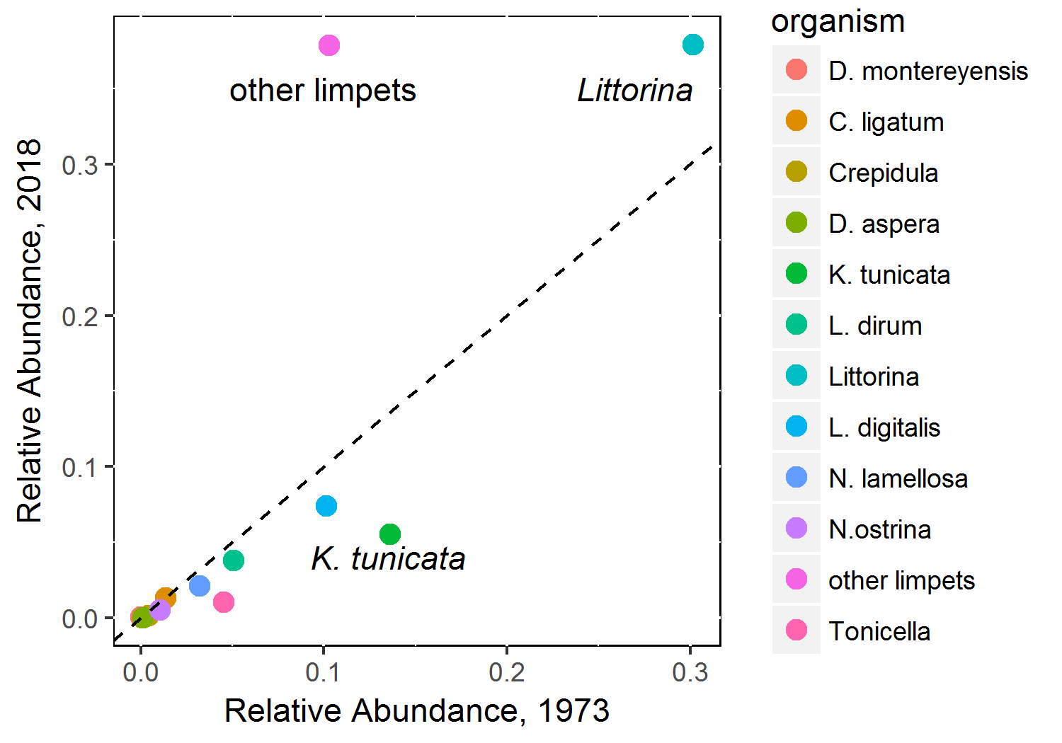**Figure 4 - *Historical versus contemporary relative abundance of mollusks at Dead Man’s Bay*. Dashed line shows trend expected if relationship between historical and relative abundance were in a 1:1 ratio. Species groups which were far from the 1:1 line are labelled with names; *K. tunicate = Katharina tunicate; Littorina = all Littorine snails;* other limpets = limpets excluding Lottia digitalis and Diodora aspera. Relative abundance is equal to the total individuals in the species group counted divided by the total number of mollusks counted, across the entire survey.**

**Table 3 - *Relative Abundances of Mollusk Groups at Dead Man’s Bay, 1973 versus 2018*. Other limpets refers to all limpets excluding *Lottia digitalis* and *Diodora aspera*.**

|  |  |  |
| --- | --- | --- |
| Organism | Relative Abundance  1973 2018 | |
| Doris montereyensis | 0.000 | <0.001 |
| Calliostoma ligatum | 0.014 | 0.013 |
| Crepidula | 0.004 | 0.001 |
| Diodora aspera | 0.001 | 0.000 |
| Katharina tunicata | 0.136 | 0.055 |
| Lirabuccinum dirum | 0.051 | 0.038 |
| Littorina | 0.302 | 0.379 |
| Lottia digitalis | 0.101 | 0.074 |
| Nucella lamellosa | 0.032 | 0.021 |
| Nucella ostrina | 0.011 | 0.005 |
| Other limpets | 0.103 | 0.379 |
| Tonicella | 0.045 | 0.010 |

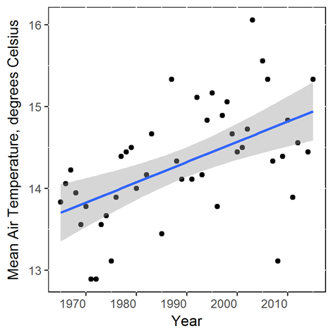

* **Figure 5 – *Annual mean air temperatures on Orcas Island* *from 1965 to 2018*. Blue line shows linear regression. Data collected from station Olga SE2, station ID: GHCND:USC00456096 on Orcas Island.**

Aerial temperature measured by NOAA on Orcas Island shows an increase of approximately 1ºC from 1973 to 2015(Fig. 5; [www.ncdc.noaa.gov](http://www.ncdc.noaa.gov)). A complete set of Race Rocks, Juan de Fuca, British Columbia temperature data from 1973 to 2018 is not publicly accessible, but they report since 1921 there has been a 1ºC increase in the surface temperature of Haro Strait.

Discussion

We set out to evaluate how mollusk populations had changed in the intertidal of Dead Man’s Bay and found that largely population density and relative abundance was not meaningfully different from 1973. There remains a considerable amount of variability in population densities across species, and considerable variability within species across the intertidal. For the groups that saw an ecologically meaningful shift in density or relative abundance, there was an interesting pattern. The species that showed substantial increase were *Littorina* and limpets, which are on the smaller end of body size, while the specie that saw a substantial decrease in relative abundance was *Katharina tunicata*, a much larger mollusk. This pattern matches our hypothesis under increased warming and decreased pH. An alternate approach to quantifying relative abundance would compare relative biomass. To determine whether this pattern is still present when taking into account biomass, we would need data on average biomass of individuals of each of the species we considered and then would compare relative total biomass rather than relative counts. This could allow us to avoid biasing small organisms over large ones, and would give another layer of confidence to our analysis.

Locally collected temperature and pH data shows trends we expect under climate change and ocean acidification. On top of evidence that air and sea surface temperatures have risen, we had access to site specific measurements. At Dead Man’s Bay, other researchers have collected data on tide pool temperature and pH. Rebecca Guenther reports Dead Man’s Bay tide pool temperatures in the summer always exceeded the temperature of the sea surface water, and that temperatures could exceed 30ºC in the summer (Guenther *unpublished*). While we did not find data on pH at Dead Man’s Bay from the 1970’s, in recent years researchers have collected pH data at the site. Average incoming sea water pH to Dead Man’s Bay varied seasonally; 7.9 in winter and 7.7 (Guenther *unpublished*). Similary, pH varied seasonally within tide pools, with significant differences from the incoming sea water at the end of isolation between tides; pH ranged from 7.9 to 7.5 in the winter and from 7.6 to 8.4 in the summer with pH increasing in tide pools over the course of tidal isolation(Guenther *unpublished*). Together, this is all indication climate change is occurring locally, and its impacts on local communities is worth consideration.

Previous studies looking at the impacts of temperature and pH on gastropods have used manipulation experiments to predict the possible implications of climate change and ocean acidification, but often are in the lab and also often on small time scales. While our study does not allow us to directly connect temperature or pH to the community changes we saw, it shows those changes over a much longer time scale. Additionally, it has the benefit of being in-situ, meaning that we looked at what is actually happening in the intertidal. We show that within the most abundant mollusk genera at Dead Man’s Bay there are changes that are correlated with what we would expect given current warming, acidification, and our understanding of molluscan biology.

Previous studies have shown that temperature and pH play important roles in community dynamics and success of mollusks (Bibbey et al 2007; Melatunan et al 2013; Yamane and Gilman 2009). *Littorina littorea*, a member of the same genus of snails most abundant at Dead Man’s Bay, lose their induced defenses as pH decreases (Bibbey et al 2007). This means that they stop growing thicker shells in response to signals from their predator, crabs. Melatunan similarly found that increasing temperature and decreasing pH caused an overall decrease in *Littorina littorea* shell thickness (Melatunan et al 2013). If this is the case for our species of *Littorina*, having reduced shell thickness would make them more susceptible to predation, and so we might expect them to have decreased in number due to predation, and potentially an increase in those predators, however neither is the case. *Cancer productus* and *Nucella lamellosa* are the main predators of *Littorina*, but we found zero *Cancer productus*, and found no ecologically meaningful change in *Nucella lamellosa* from 1973 (Toler-Scott *unpublished*). An alternate consideration is that small mollusks have increased thermal stress tolerance compared to larger mollusks (Peck et al 2009). This may also be a factor in the decline we see in *Katharina tunicata*. It is also important to note that impacts of thermal stress may be complicated by the differences in how aerial temperature and water temperature affect mollusks (Yamane and Gilman 2009). Another species from our study, *Nucella ostrina,* showed a drastic reduction in feeding rate on *Balanus glandula* when exposed to increased air temperatures, but increased water temperature had the opposite effect of greatly increasing feeding rates (Yamane and Gilman 2009). While the mechanism behind the decrease caused by increased air temperature is unclear, warmer water temperature increases metabolism, allowing for quicker turn around in feeding (Yamane and Gilman 2009).

When looking at these changes it is also important to consider community context and factors beyond climate change. We previously addressed the lack of relationship between changes in *Littorina* and their predators, but trophic interactions may be important in other cases, particularly for *Katharina tunicata*. In the algae, we saw a steep decrease in *Saccharina sessilis* and a general decrease in canopy algae whose juveniles serve as a critical food source for *Katharina tunicata* (Dougherty 2018 data*;* May, Steinhebel, and Sutter 2018 data). The reduction in food source is another possible culprit in the decline of *Katharina tunicata.* Loss of canopy coverage can also allow for an increase in microalgal growth, the main food source for the limpets we saw an increase of density and abundance in (Steinhebel 2018; Stutter 2018; Duggins and Dethier 1985). While some of these changes may possibly be influenced by climate change, the effects are not necessarily direct.

In general, the intertidal is spatially variable, making it difficult to assert changes or similarities measured in it are due to legitimate changes or differences in sampling; further resurveys in Dead Man’s would allow us to be more confident in observed trends. The lack of documentation of historical transect and quadrat locations meant we do not know how equally representative the two studies are of the Dead Man’s intertidal. For this reason, we have included GPS coordinates for our survey transects and quadrats to allow future researchers a greater point of comparison. Studies in future years would provide a better means of comparison and increase temporal resolution. Collecting longer-term data at the site of tide pool and incoming water temperature and pH, like by Guenther, would better allow us to understand how conditions are specifically changing at Dead Man’s Bay. Measurement of tidal elevation would also allow us to better characterize individual quadrats. We can also not overstate the value of looking for cascading effects, as these organisms exist as part of a community.

Intertidal communities like that at Dead Man’s Bay can serve as a valuable resource in the continued study of climate change. The variety of organisms and range in conditions can provide a testing ground for hypotheses generated by laboratory experiments, especially in the context of historical data sets. The path forward may become clearer if we first look back and compare it with now. From this study, we see that there is a trend towards increases in the smallest mollusks, and a decline in larger mollusks, and that these changes may be part of larger community shifts in line with our expectations under climate change. This historical approach and observations can serve as a jumping off point for future studies into changing community dynamics in a changing world.

Acknowledgements

I would like to thank the Mary Gates Endowment, for partially funding this research experience.

References

Angilletta, M.J. 2009. Looking for answers to questions about heat stress: researchers are getting warmer. Functional Ecology 23: 231-232.

Bhadury, P. 2015. Effects of ocean acidification on marine invertebrates- a review. Indian Journal of Geo-Marine Sciences 44:454-464.

Bibby, R., P. Cleall-Harding, S. Rundle, S. Widdicombe, and J. Spicer. 2007. Ocean acidification disrupts induced defences in the intertidal gastropod Littorina littorea. Biology Letters 3:699-701.

Bjelde, B. E., and A. E. Todgham. 2013. Thermal physiology of the fingered limpet Lottia digitalis. Journal of Experimental Biology 216: 2858-2869.

Dougherty, S. 2018. Loss of *Saccharina sessilis* in Deadman’s Bay: an assessment of an algal regime shift in the Northeast Pacific. Unpublished, UW-FHL collection.

Duggins, D.O., and M.N. Dethier. 1985. Experimental studies of herbivory and algal competition in a low intertidal habitat. Oecologia 67: 183-191.

Dwinell, L., H. Hastings, M. Johnson, C. Reed, and W.H. Zachritz. 1973. Survey of the intertidal flora and fauna of Dead Man’s Bay, San Juan Island. Unpublished, UW-FHL collection.

Feely, R.A., Sabine, C.L., Lee, K., Berelson, W., Kleypas, J., Fabry, V.J., and F.J. Millero. 2004. Impacts of anthropogenic CO2 on the CaCO3 system in the oceans. Science 305: 362-366.

Helmuth, B., Mieszkowska, N., Moore, P., and S.J. Hawkins. 2006. Living on the edge of two changing worlds: forecasting the responses of rocky intertidal ecosystems to climate change. Annual Review of Ecology, Evolution, and Systematics 37: 373-404.

Melatunan, S., P. Calosi, S. D. Rundle, S. Widdicombe, and A. J. Moody. 2013. Effects of ocean acidification and elevated temperature on shell plasticity and its energetic basis in an intertidal gastropod. Marine Ecology Progress Series 472:155-168.

Morelissen, B. and C.D.G. Harley. 2007. The effects of temperature on producers, consumers, and plant-herbivore interactions in an intertidal community. Journal of Experimental Marine Biology and Ecology 348: 162-173.

Murray, J.W., Roberts, E., Howard, E., O’Donnell, M., Bantam, C., Carrington, E., Foy, M., Paul, B., and A. Fay. 2015. An inland sea high nitrate-low chlorophyll (HNLC) region with naturally high pCO2. Limnology and Oceanography 60: 957-966.

NOAA National Centers for Environmental information, Climate at a Glance: Global Time Series, published May 2018, retrieved on May 20, 2018 from http://www.ncdc.noaa.gov/cag/

Ohlberger, J. 2013. Climate warming and ectotherm body size – from individual physiology to community ecology. Functional Ecology 27: 991-1001.

Peck, S.L., Clark, M.S., Morley, S.A., Massey, A., and H. Rossetti. 2009. Animal temperature limits and ecological relevance: effects of size, activity and rates of change. Functional Ecology 23: 248-256.

Pfister, C.A., Berry, H.D., and T. Mumford. 2017. The dynamics of kelp forests in the Northeast Pacific Ocean and the relationship with environmental driver. Journal of Ecology 1-14.

Sheridan, J.A., and D. Bickford. 2011. Shrinking body size as an ecological response to climate change. Nature Climate Change. 1: 401-406.

Silbiger, N.J., and C.J.B. Sorte. 2018. Biophysical feedbacks mediate carbonate chemistry in coastal ecosystems across spatiotemporal gradients. Scientific Reports 8:796.

Steinhebel, H. 2018. The effects of temperature change on *Katharina tunicata* and intertidal population dynamics. Unpublished, UW-FHL collection.

Sutter, K. 2018. Ecological survey of intertidal mollusks, algae and their community interactions. Unpublished, UW-FHL collection.

Toler-Scott, C. 2018. A comparison of the historical and contemporary population densities of barnacle and crab populations within the intertidal of Deadman Bay, San Juan Island. Unpublished, UW-FHL collection.

Yamane, L. and S.E. Gilman. 2009. Opposite responses by an intertidal predator to increasing aquatic and aerial temperatures. Marine Ecology Progress Series 393: 27-36.

Appendices

Species Observed at Dead Man’s Bay on 20 April 2018

*\**represent species which were present in our survey on 20 April 2018 but were not noted in 1973.

+represents species identified after 20 April 2018 on survey days in May 2018

**Invertebrates**

**Cnidaria**

*Anthopleura elegantissima*

*Anthopleura artemisia\**

*Epiactus sp.\**

*Urticina cassicornis\**

**Ctenophora**

*Pleurobrachia sp.\**

**Crustacea**

*Balanus glandula*

*Cancer productus\**

*Hemigrapsus nudus*

*Heptacarpus sp.\**

*Idotea sp.\**

*Lophopanopeus bellus\**

*Pagarus sp.*

*Petrolisthes sp.\**

*Puggetia gracilis*

*Semibalanus cariosus*

**Echinodermata**

*Cucumaria miniata\**

*Leptasterias hexactis*

*Henricia sp.\**

*Strongylocentrotus droebachiensis*

*Strongylocentrotus franciscanus\**

*Strongylocentrotus purpuratus\**

**Mollusca**

**Polyplacophora**

*Cryptochiton stelleri\**

*Katharina tunicate*

*Mopalia sp.*

*Tonicella sp.*

**Gastropoda**

**Opistobranchia**

*Aeolidia papillosa\**

*Archidoris montereyensis*

*Onchidoris*

*Rostanga pulchara\**

**Prosobranchia**

*Calliostoma ligatum*

*Diodora aspera*

*Littorina sp.*

*Lottia digitalis*

*Lottia mitra*

*Lottia pelta*

*Nucella emarginata*

*Nucella lamellosa*

*Tectura persona*

*Tectura scutum*

**Bivalvia**

*Mytilus sp.*

**Porifera**

*Halicondria sp.\**

*Ophiliaspongia pennata*

**Worms**

**Nemertea**

*Tubulanus polymorphus\**

**Polychaeta**

Sabellidae

**Algae**

**BROWN**

*Fucus distichlis*

*Egregia menziesii\**

*Alaria marginata*

*Costaria costata\**

*Saccharina sessile*

*Saccharina latissima*

*Nereocystis leutkeana\**

*Leathesia difformis*

*Scytosiphon lomentaria\**

*Neorhodomela sp.*

*Prasiola meridionalis*

*Desmarestia sp.*

*Desmarestia aculeate\**

***GREEN***

*Ulva sp.*

*Acrosiphonia coalita*

*Phyllospadix scouleri\**

***RED***

*Mazzaela splendens\**

*Sparlingia pertusa*

*Polysiphonia collinsi*

*Endocladia muricate*

*Mastocarpus papillatus*

*Petrocelis (Mastocarpus)*

*Palmaria palmata\**

***CORALLINES***

*Calliarthron regenerans*

*Bossiela sp.*

Species Counted in Contemporary Study

**Cnidaria**

*Anthopleura elegantissima*

*Epiactus sp.*

*Urticina cassicornis*

**Crustacea**

*Balanus glandula*

*Cancer productus*

*Hemigrapsus nudus*

*Heptacarpus sp.*

*Idotea sp.*

*Lophopanopeus bellus*

*Pagarus sp.*

*Puggetia gracilis*

*Semibalanus cariosus*

**Echinodermata**

*Cucumaria miniata*

*Leptasterias hexactis*

*Henricia sp.*

*Strongylocentrotus droebachiensis*

*Strongylocentrotus franciscanus*

*Strongylocentrotus purpuratus*

**Mollusca**

**Polyplacophora**

*Cryptochiton stelleri*

*Katharina tunicata*

*Mopalia sp.*

*Tonicella sp.*

Other chitons lumped

**Gastropoda**

**Opistobranchia**

*Aeolidia papillosa*

*Doris montereyensis*

*Onchidoris*

*Rostanga pulchara*

**Prosobranchia**

*Bittium sp.*

*Calliostoma ligatum*

*Diodora aspera*

*Littorina sp.*

*Lottia digitalis*

*Lottia mitra\**

*Lottia pelta\**

*Nucella emarginata*

*Nucella lamellosa*

*Tectura persona\**

*Tectura scutum\**

*lumped into group “other limpets”

**Bivalvia**

*Mytilus sp.*

Coordinates for Quadrats Surveyed in May 2018

|  |  |  |  |
| --- | --- | --- | --- |
| Transect # | Quadrat Distance on Transect [m] | latitude | longitude |
| 5 | 30 | 48˚ 30' 47.00" N | 123˚ 8' 48.35" W |
| 5 | 21 | 48˚ 30' 47.28" N | 123˚ 8' 48.24" W |
| 5 | 13 | 48˚ 30' 47.45" N | 123˚ 8' 48.14" W |
| 5 | 8 | 48˚ 30' 47.66" N | 123˚ 8' 47.99" W |
| 5 | 32 | 48˚ 30' 46.93" N | 123˚ 8' 48.46" W |
| 5 | 24 | 48˚ 30' 47.10" N | 123˚ 8' 48.31" W |
| 5 | 35 | 48˚ 30' 46.85" N | 123˚ 8' 48.50" W |
| 5 | 38 | 48˚ 30' 46.74" N | 123˚ 8' 48.58" W |
| 5 | 42 | 48˚ 30' 46.66" N | 123˚ 8' 48.70" W |
| 5 | 34 | 48˚ 30' 46.84" N | 123˚ 8' 48.48" W |
| 3 | 5 | 48˚ 30' 47.89" N | 123˚ 8' 50.54" W |
| 3 | 18 | 48˚ 30' 47.53" N | 123˚ 8' 50.79" W |
| 3 | 21 | 48˚ 30' 47.47" N | 123˚ 8' 50.76" W |
| 3 | 19 | 48˚ 30' 47.48" N | 123˚ 8' 50.78" W |
| 3 | 16 | 48˚ 30' 47.54" N | 123˚ 8' 50.74" W |
| 3 | 10 | 48˚ 30' 47.84" N | 123˚ 8' 50.63" W |
| 3 | 7 | 48˚ 30' 47.83" N | 123˚ 8' 50.58" W |
| 3 | 8 | 48˚ 30' 47.91" N | 123˚ 8' 50.56" W |
| 3 | 15 | 48˚ 30' 47.60" N | 123˚ 8' 50.71" W |
| 3 | 3 | 48˚ 30' 47.86" N | 123˚ 8' 50.61" W |
| 2 | 17 | 48˚ 30' 47.39" N | 123˚ 8' 49.94" W |
| 2 | 12 | 48˚ 30' 47.56" N | 123˚ 8' 49.95" W |
| 2 | 10 | 48˚ 30' 47.63" N | 123˚ 8' 49.95" W |
| 2 | 31 | 48˚ 30' 46.96" N | 123˚ 8' 50.17" W |
| 2 | 27 | 48˚ 30' 47.11" N | 123˚ 8' 50.16" W |
| 2 | 20 | 48˚ 30' 47.26" N | 123˚ 8' 50.02" W |
| 2 | 21 | 48˚ 30' 47.24" N | 123˚ 8' 50.03" W |
| 2 | 24 | 48˚ 30' 47.13" N | 123˚ 8' 50.09" W |
| 2 | 5 | 48˚ 30' 47.71" N | 123˚ 8' 49.94" W |
| 2 | 25 | 48˚ 30' 47.10" N | 123˚ 8' 50.02" W |
| 6 | 21 | 48˚ 30' 47.60" N | 123˚ 8' 49.68" W |
| 6 | 12 | 48˚ 30' 47.37" N | 123˚ 8' 49.78" W |
| 6 | 18 | 48˚ 30' 47.55" N | 123˚ 8' 49.67" W |
| 6 | 20 | 48˚ 30' 47.63" N | 123˚ 8' 49.73" W |
| 6 | 16 | 48˚ 30' 47.39" N | 123˚ 8' 49.92" W |
| 6 | 16 | 48˚ 30' 47.46" N | 123˚ 8' 49.73" W |
| 6 | 25 | 48˚ 30' 47.65" N | 123˚ 8' 49.70" W |
| 6 | 7 | 48˚ 30' 47.13" N | 123˚ 8' 50.01" W |
| 6 | 2 | 48˚ 30' 46.99" N | 123˚ 8' 50.04" W |
| 6 | 9 | 48˚ 30' 47.20" N | 123˚ 8' 49.96" W |

*Raw data and R scripts have also been provided to the Friday Harbor Labs Library for both*

*invertebrates and algae.*